16A cable / cable marker
32A cable / unlabelled
Battery cable
Multiplug connection

Sylva Mojo 2 wiring diagram

Key
FL Front Left
FR Front Right
RL Rear Left
RR Rear Right
IL Indicator Lamp

SR Side Repeater
MB Main Beam
DP Dip Beam
SL Side Light
PB Piggy Back connector

7

PB

ECU
Pin 11

RR

20A Fuse
F13

55

ECU

Pin 24

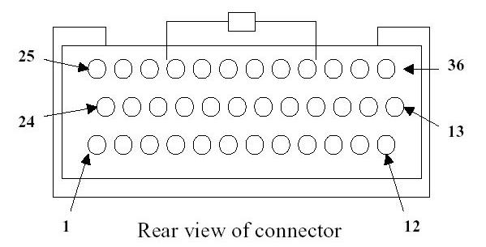
85

86

87

30

ECU
Pin 28

ECU
Pin 4

PB

ECU

Pin 25

Coil
pack

ECU

Pin 5

Injectors
1 & 4

ECU

Pin 23

Injectors
2 & 3
1 & 4
2 & 3
0.1A
85

86

87

30

85

86

87

30

87a

85

86

87

30

87a

85

86

87

30

0.6A
3.2A
0.1A
1.8A
1.9A
5.2A
85

86

87

30

5A
10A
10A
10.1A
10.1A
0.1A
1.8A
1.8A
0.1A
5.3A
17.1A
85

86

87

30

0.1A
Reed switch
0.1A
5.1A
8.6A
5A
F12

F1

F2

F3

F9

F7

F8

18.3A
Speedo signal
Isolator
Ign

Start

Dip

Main

15A Fuse

60W
MB
5A

1W MB
Warn
0.1A
Battery +ve

Head-
lights
Sidelights
Foglight
60W
MB
5A

21W
Fog
1.8A

1W Fog
Warn
0.1A

5W No, plate lamp
0.5A
21W BL
1.8A

15A Fuse

7W
FR SL
0.6A

5W
RL SL
0.5A

7W
FL SL
0.6A

5W
RR SL
0.5A

5A Fuse

60W
FR DB
5A

60W
FL DB
5A

7.5A Fuse

7.5A Fuse

49a

31

49

10A Fuse

Hazard
Indicator
21W
RL IL
1.8A

5W
L SR
0.5A

21W
RR IL
1.8A

5W
R SR
0.5A

Acc

0.5A
1A
0.5A
0.5A
0.6A
0.1A
2A
21W BL
1.8A

15A Fuse

5A
5A
0.1A
0.1A
8.1A
1.8A
0.5A
0.5A
1.8 / 2.4A
8.4A
4.2A
Radiator
fan
8.1A
4.2A / 8.4A
Left indicators

Right indicators

Side lights

Brake

lights
Fog lights
Dip beam
Main
beam
Horn
Starter solenoid
Starter
Alternator
10A Fuse

25A Fuse
MPH

°C

BAR

Flasher unit
A

A

B

B

C

C

5A Fuse

20A Fuse
5A Fuse

0.1A
PB

PB

PB

PB

PB

R1

R4

F10
F6

F5

21

8

2

10

9

R3

R2A

R1A

R5

R2

PB

13.1A
PB

F11
10.2A
87

98

12

76

43

54

8.1A
13.4A
23

11
22
22
22
11
11
11
11
90
90
90
89
89
67
56
78

78

8

15

12V Socket
1W
Brake warn
0.1A

0.1A
ECU
Pin 20

0.1A
7

40

55

0.1A
Hand-brake
Brake reservoir
Fuel
pump

6

1

0.1A
F4

85

86

87

30

R6

Shiftlight LED

99

3.6A

ECU

Pin 19

PB

3

16

97

Brake pedal
ECU
Pin 6

Brake pressure
12V socket
34

1W Charge warn
0.1A
PB

60

88

33

60

PB

8A
1.8A
5A
ECU
Pin 12

1.8A
Wiper motor
Wiper
Washer
Heater blower motor
100W 8A
Washer pump
Fuel. sender
4

?A
1.8A / 2.4A
1
33

Park
13

77

44

0

%

Temp. sender
Pres.. sender
A

B

C

8A
5

22

RPM

1.8A
65

22 used twice by mistake! Do not confuse with indicator circuit 22!
22
65

21W
FL IL
1.8A

1W
L IL
Warn
0.1A

22
32

5x1W
Instrument back-lights
0.5A

66
21W
FR IL
1.8A

1W
R IL
Warn
0.1A

89

Neil Everett

